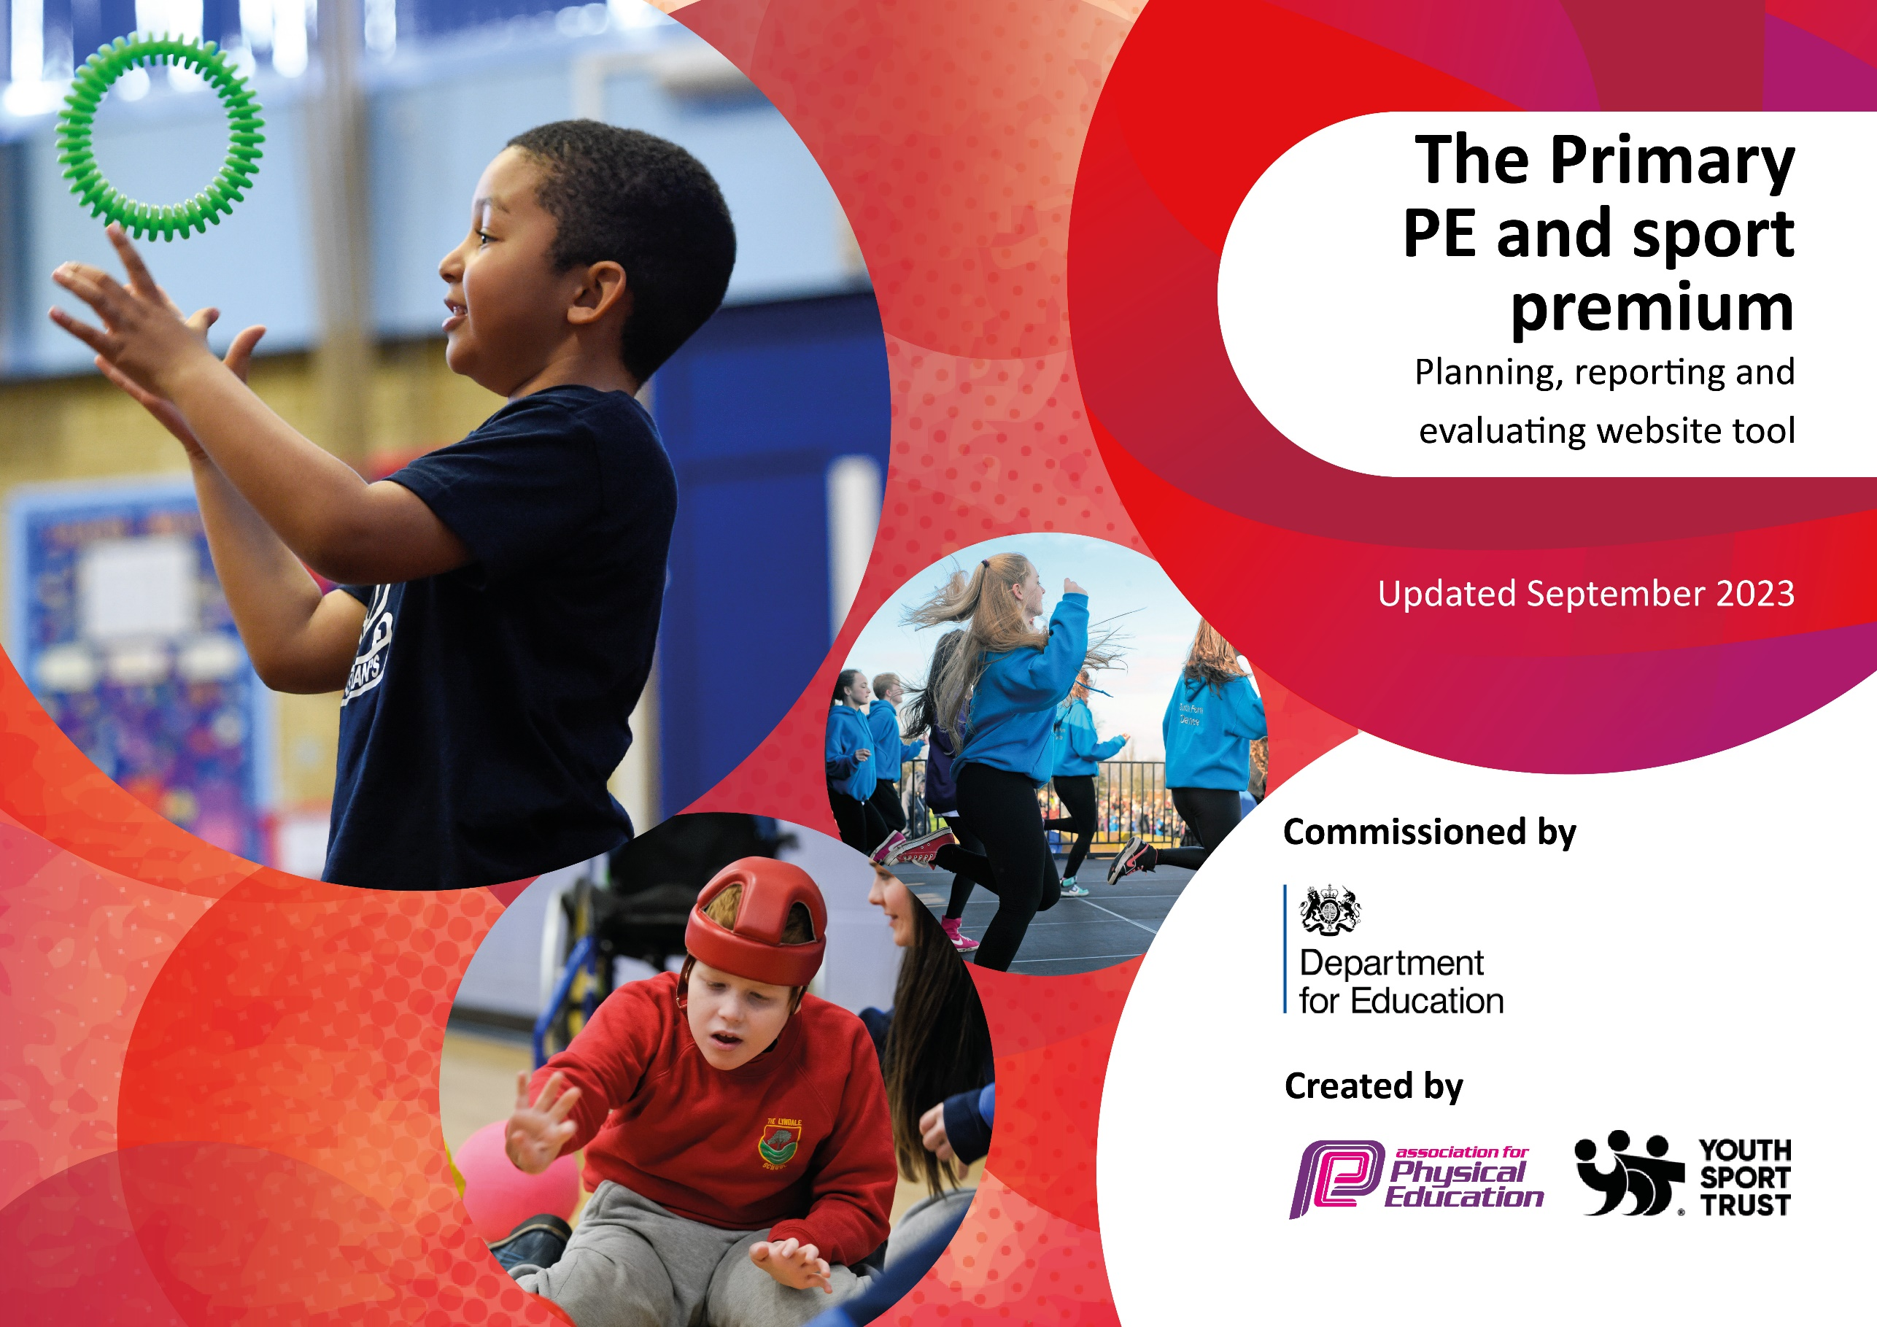

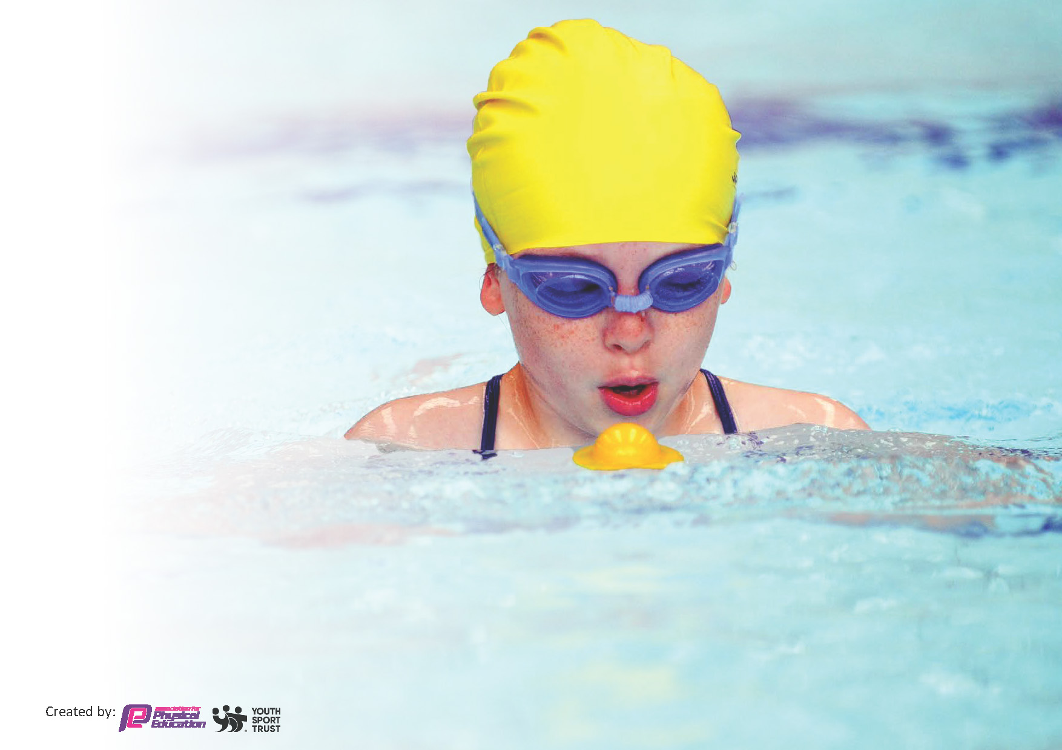
This template can be used for multiple purposes:
by:
- It enables schools to effectively plan their use of the Primary PE and sport premium
- It helps schools to meet the requirements (as set out in guidance) to publish information on their Primary PE and sport premium
- It will be an effective document to support Ofsted inspections enabling schools to evidence progress in Physical Education (PE) and evidence swimming attainment, which forms part of the PE National Curriculum. We would recommend schools consider
the Intent, Implementation and Impact of any spend, as examined within the Education Inspection Framework.

It is important that your grant is used effectively and based on school need.

Schools must use the funding to make additional and sustainable
improvements to the quality of the PE, School Sport and Physical Activity (PESSPA)
they offer. This means that you should use the Primary PE and sport premium to:

- Build capacity and capability within the school to ensure that improvements made now will benefit pupils joining the school in future years
- Develop or add to the PESSPA activities that your school already offers.

The Primary PE and sport premium should not be used to fund capital spend projects; the school’s core budget should fund these. Further detail on capital expenditure can be found in the updated Primary PE and sport premium guidance.

The Primary PE and sport premium guidance, outlines 5 key priorities that funding should be used towards. It is not

necessary that spending has to meet all the key priorities, you should select the priorities that you aim to use any funding towards.

Although completing this template is not a requirement for schools, schools are required to publish details of how they spend this funding. Schools must also outline what the impact this funding has had on pupils’ PE and sport participation and attainment and how any spending will be sustainable in the future. All funding must be spent by 31st July 2024.

The Department for Education has worked closely with the Association for Physical Education (afPE) and the Youth Sport Trust (YST) to develop this template and encourages schools to use it. This template is an effective way of meeting the reporting requirements of the Primary PE and sport premium.
Review of last year’s spend and key achievements (2023/2024)

We recommend you start by reflecting on the impact of current provision and reviewing your previous spend.

Activity/Action | Impact | Comments
Please see evaluation on 24 plan on website.

Key priorities and Planning
This planning template will allow schools to accurately plan their spending.

Action – what are you planning to do | Who does this action impact? | Key indicator to meet | Impacts and how sustainability will be achieved? | Cost linked to the action
- Pupils plan, deliver and participate in at least 15 mins active playtimes to support 30 active minutes  - All pupils have access to more organised activities at lunchtime and an opportunity to voice what activities are on offer. The take up is good and pupil voice indicates enjoyment  - Pupils are targeted with activities to involve and encourage the least active.  - Pupils show leadership in organising and officiating these opportunities (25% of Y3 – 6 )  - Zoned areas of the playground continue to support: busy playtimes; increased choice; activeness; happy playtimes; both formal games and more creative games | Lunchtime supervisors / teaching staff, coaches - as they need to lead the activity  pupils – as they will take part. | Key indicator 2 -The engagement of all pupils in regular physical activity – the Chief Medical Officer guidelines recommend that all children and young people aged 5 to 18 engage in at least 60 minutes of physical activity per day, of which 30 minutes should be in school.  Key indicator 4: Broader experience of a range of sports and activities offered to all pupils. | More pupils meeting their daily physical activity goal, more pupils encouraged to take part in PE and Sport Activities. | £1000 costs for additional coaches to support lunchtime sessions. £220 for resources.  Proportion of £4000 (Lacon Childe Partnership) - Jumping Jaxx leadership training  Proportion of staff lead/champion (£1800 overtime and higher grade)
- Continue to upgrade playground markings to support 15 minutes daily mile and zoned activities (particularly former) | Pupils  Teaching staff, coaches  Lunchtime staff | Key Indicator 2: Increasing engagement of all pupils in regular physical activity and sport | More pupils meeting their daily physical activity goal, more pupils participating in pupil led games and activities | £1000
- Change school uniform to include footwear that would be appropriate to run the mile run without having to change | Pupils  Parents  Teaching staff | Key Indicator 2: Increasing engagement of all pupils in regular physical activity and sport | More pupils meeting their daily physical activity goal. Curriculum time is optimized (changing reduced) which supports staff in maintaining initiative. | £200 admin time.
- All pupils access a broad programme of Level 1, Level 2 and (where appropriate) Level 3 competition. This supports enjoyment and develops skill.  - Celebrate and value participation and enjoyment on the sports board | Pupils  Teaching staff | Key Indicator 1: Increasing all staff’s confidence, knowledge and skills in teaching PE and sport  Key Indicator 2: Increasing engagement of all pupils in regular physical activity and sport  Key Indicator 3: raising the profile of PE and sport across the school to support whole school improvement  Key Indicator 4: Offer a broader and more equal experience of a range of sports and physical activities to all pupils  Key Indicator 5: Increase participation in competitive sport | More pupils enjoying and participating in competitive opportunities  Providing equal access to sport | Proportion of £4000 (Lacon Childe Partnership) -  Transportation costs £3000  KS2 c. 2 x per half term £2250  KS1 c 1 per half term £525  Reception c 1 per term £225  Proportion of staff lead/champion (£1800 overtime and higher grade)
- To build Nursery/EYFS staff confidence in providing fundamental movement skills | Nursery staff  Nursery pupils | Key Indicator 1: Increasing all staff’s confidence, knowledge and skills in teaching PE and sport  Key Indicator 2: Increasing engagement of all pupils in regular physical activity and sport  Key Indicator 4: Offer a broader and more equal experience of a range of sports and physical activities to all pupils | Core movement skills are supported and developed in our youngest pupils | Staff meeting time (overtime £200)  Staff CPD (£200)  EYFS teacher in Nursery sessions
- Curriculum provision is strengthened and complimented by outside provider visits e.g. Bridgnorth Tennis, Kiddy Harriers Football, Rugby, Dance and Gymnastics  - Offer a programme of activity after school daily which is popular with the children – use questionnaire and pupil voice to gauge this. Pupils are targeted with activities to involve and encourage the least active (gender; FSM; SEN). Consider supporting transition needs (Y2/3 and Y6/7). Consider reusing the Shrewsbury Town Transition.  - At least 80% participate in extra-curricular every week (Y3 – 6 but also aim for the whole school)  - Celebrate and value what children do outside school - use questionnaire  - 90% of pupils participate in extra-curricular sport every week (in or outside of school) | Pupils and Teaching staff | Key Indicator 4: Offer a broader and more equal experience of a range of sports and physical activities to all pupils  Key Indicator 1: Increasing all staff’s confidence, knowledge and skills in teaching PE and sport | More pupils enthused to take part in PE and Sport Activities. Links to outside clubs encourage participation outside of school. Staff expertise supported by seeing coaches deliver in specialist areas. | C£200 for a half term programme – consider 1 each term = £600  Upper KS2 1 half term set of lessons -= £600  Proportion of £4000 (Lacon Childe Partnership) -  £200 top up for after school clubs e.g. to boost when initial uptake is lower.  Proportion of staff lead/champion (£1800 overtime and higher grade)  Funding to support transition programmes (£400)
- To continue to confirm our OAA offer including the skills and knowledge that will be secured.  - Consider whether each class could do a visit to Pool Meadow for an OAA activity  - Develop OAA activities on own site (use Lacon resources) | Pupils  Teaching staff | Key Indicator 4: Offer a broader and more equal experience of a range of sports and physical activities to all pupils  Key Indicator 1: Increasing all staff’s confidence, knowledge and skills in teaching PE and sport | Tracking sheets and summative data show knowledge and skills gained. | Support costs of OAA experience (£600)  CPD for staff to complement with on site activities (£200)  Proportion of staff lead/champion (£1800 overtime and higher grade)
- To continue to check our parity of provision e.g. for girls and boys; for SEN; for FSM  - Use Arbor to review uptake on a termly basis | All pupils | Key Indicator 4: Offer a broader and more equal experience of a range of sports and physical activities to all pupils  Key Indicator 1: Increasing all staff’s confidence, knowledge and skills in teaching PE and sport | School games mark criteria of equal opportunities are met and understood. | CPD £200  Proportion of staff lead/champion (£1800 overtime and higher grade)
- To target pupils to meet national curriculum swimming targets (specifically Y5/6 pupils who may need additional provision and support)  - To consider how to meet the increasing gap in swimming skills | Y5/6 pupils who need targeting of swimming skills | Key Indicator 2: Increasing engagement of all pupils in regular physical activity and sport  Key Indicator 4: Offer a broader and more equal experience of a range of sports and physical activities to all pupils | Swimming skills are boosted which results in future provision being more manageable and back on track | Additional minibus and swimming teacher for 8 sessions and increased needs in Y5 cohort (£1500)  Possible additional swimming slot (£500)  Proportion of staff lead/champion (£1800 overtime and higher grade)
- To review and amend the coherence of the curriculum (progression, knowledge and skills) and ensure pupils have enough time to develop knowledge and fluency  - To review the use of the tracking sheet to ensure efficiency and effectiveness. | Pupils  Teaching staff | Key Indicator 1: Increasing all staff’s confidence, knowledge and skills in teaching PE and sport | If our curriculum is tightened this will support the quality of delivery into the future  Tracking sheets are completed in a manageable way | Staff CPD £200 Scheme £200  Proportion of staff lead/champion (£1800 overtime and higher grade)
Total of costs/actions: £16,820
Total funding: £16,820

Key achievements 2024-2025
This template will be completed at the end of the academic year and will showcase the key achievements schools have made with their Primary PE and sport premium spending.

Activity/Action | Impact | Comments

Swimming Data
Meeting National Curriculum requirements for swimming and water safety.
Priority should always be given to ensuring that pupils can perform safe self-rescue even if they do not fully meet the first two requirements of the National Curriculum programme of study

Question | Stats: | Further context: Relative to local challenges
What percentage of your current Year 6 cohort can swim competently, confidently and proficiently over a distance of at least 25 metres?
What percentage of your current Year 6 cohort can use a range of strokes effectively [for example, front crawl, backstroke, and breaststroke]?
What percentage of your current Year 6 cohort are able to perform safe self-rescue in different water-based situations?
If your schools swimming data is below national expectation, you can choose to use the Primary PE and sport premium to provide additional top-up sessions for those pupils that did not meet National Curriculum  requirements after the completion of core lessons. Have you done this? | Yes/No
Have you provided CPD to improve the knowledge and confidence of staff to be able to teach swimming and water safety? | Yes/No

Signed off by:
Head Teacher: | Katie Jones
Subject Leader or the individual responsible for the Primary PE and sport premium: | Tracey Wood and Katie Jones
Governor: | Chris Tibbits
Date: | 22.09.24

